**CN Assignment 3**

Name: Erwin Wu

Affiliation: Koike Lab

Student ID: 17M38147

**Impression on Protein-protein interaction**

From the class on Jan.15th, we learned about Genome Science, which is consists of System Biology (to understand life as system) and Network Biology (to understand life as network). We know that lots of relationships and structures in our life can be treated as complex network, an example is our human body. These networks help us to get a better understanding of life phenomena, and there are three main kinds of architecture of network: Random network, Scale free network, and Hierarchical network.

While protein and gene expression are central rules of cells and central activities of life. And Protein-Protein Interaction is one of the cell level network of our body, it is an interaction between two or more proteins. They are predominantly based on non-covalent interactions[1] (which are usually established during transient interaction n and have weaker association compare to covalent interactions). As we all knows, a protein is composed of a long sequence of amino acids (20 types), so there are multi interactions between proteins. These interactions make up so-called interactomics of the organism, while aberrant Protein-Protein Interactions are the basis of the multiple aggregation-related diseases.

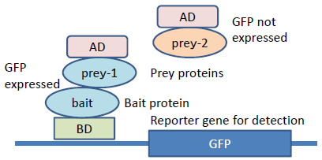 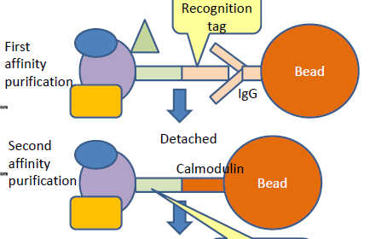

Fig 1. Yeast two-hybrid system Fig 2. Tandem Affinity Purification

During the classes, the teacher introduced several examples of the application of Protein-Protein Interactions. One of them is Y2H (Fig.1 Yeast two-hybrid system), which is a technique used to discover PPIs by testing for physical interaction (such as binding) between two proteins. GAL4 protein was introduced because it can hold a protein between AD (Active Domain) and BD (Binding Domain), which means, GAL4 can be used for PPI detection by providing Prey protein attached with AD and Bait protein attached with BD.

Another technique is the TAP (Fig.2 Tandem Affinity Purification), which is a purification for studying PPIs. In the original version of the technique, the protein of interest with the TAP tag first binds to beads coated with IgG (Immunoglobulin G) Recognition tag, the TAP tag is then broken apart by an enzyme, and finally a different part of the TAP tag binds reversibly to beads of a different type. So after the protein of interest has been washed through two affinity columns, it can be examined for binding partners.

Through this class, I gain great knowledge about how Computer Science is related with Biology and Genome Science. Since my research theme is about deep learning, there might be quite a few needs from biologist to design database. Therefore, network system is one important visualization scheme of biology. Additionally, the difference of physics or chemistry and molecular biology approaches is also a serious factor. I hope in the next class of Biological Networks I can find some practical networks for deep learning to apply.

[1] Wikipedia contributors. Non-covalent interactions. Jan 21, 2018. Available at: <https://en.wikipedia.org/wiki/Non-covalent_interactions>

[2] Zhehuan Zhao, Zhihao Yang, et al. 2016. A protein-protein interaction extraction approach based on deep neural network. International Journal of Data Mining and Bioinformatics 15(2):145–164. EGOROV, Maxim. Multi-Agent Deep Reinforcement Learning. 2016.